**Bukit Panjang Government High School**

**Subject Combination Option User Guide for Students (Express)**

**URL: https://bpghs.schoolhub.sg**

## Log in

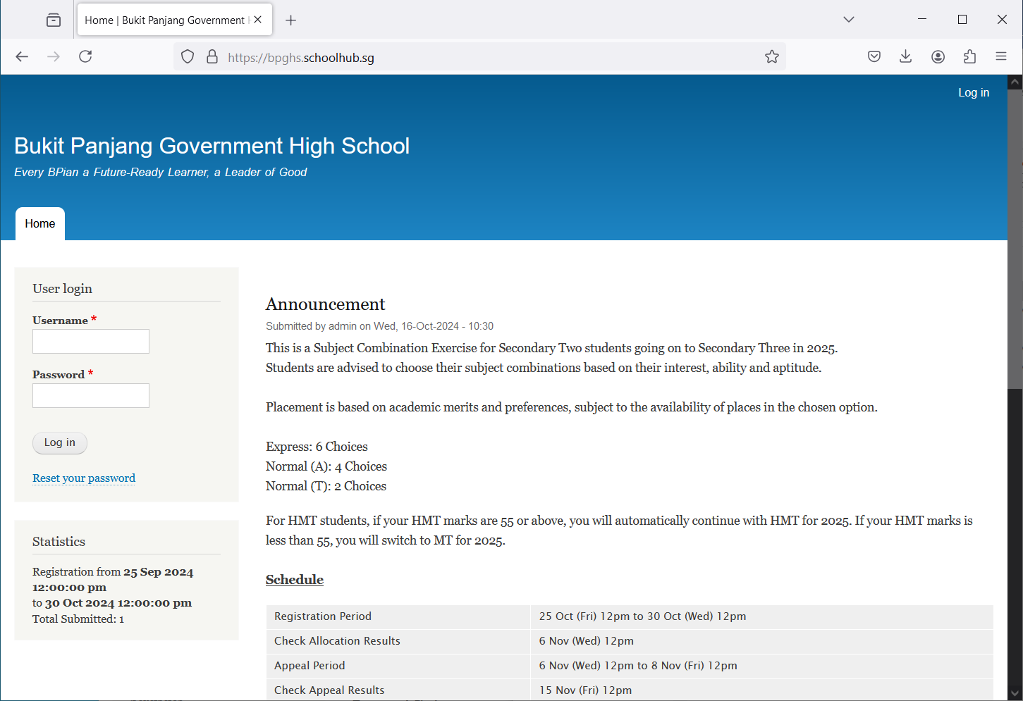

**Password Format**  
Password is date of birth in   
ddmmyyyy format

**Username Format**  
Username is first 5 characters of name and last 3 digits and alphabet of NRIC

Eg LEONA123G

Steps

* Enter Username
* Enter Password
* Click on Log in button

## Main Menu

Upon Successful login, you will see the main menu

Update your Account

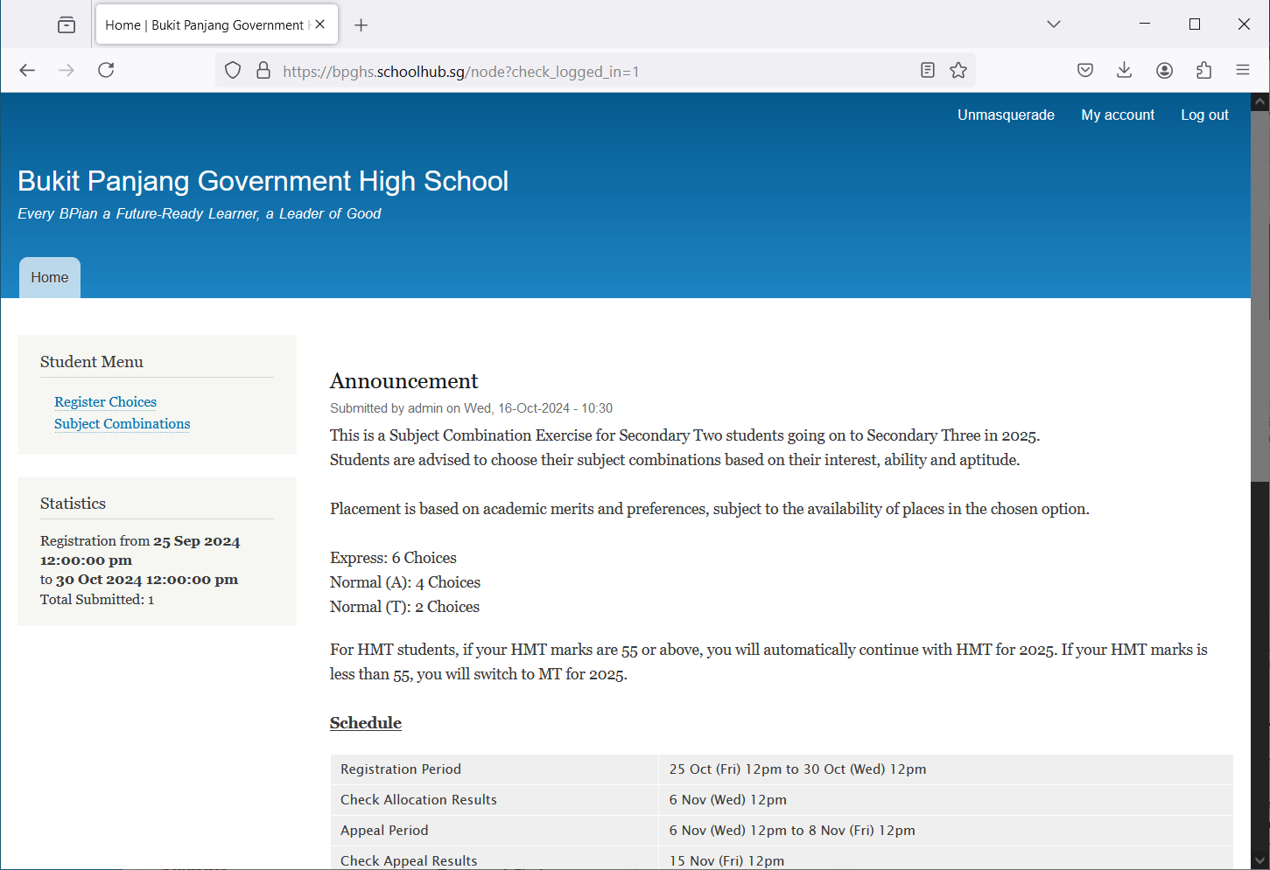

All Announcements will be posted here.

View all Subject Combinations

Update your choices

## Update User Account

You may change your password and update your eMail before you proceed to your Subject Combination choices.

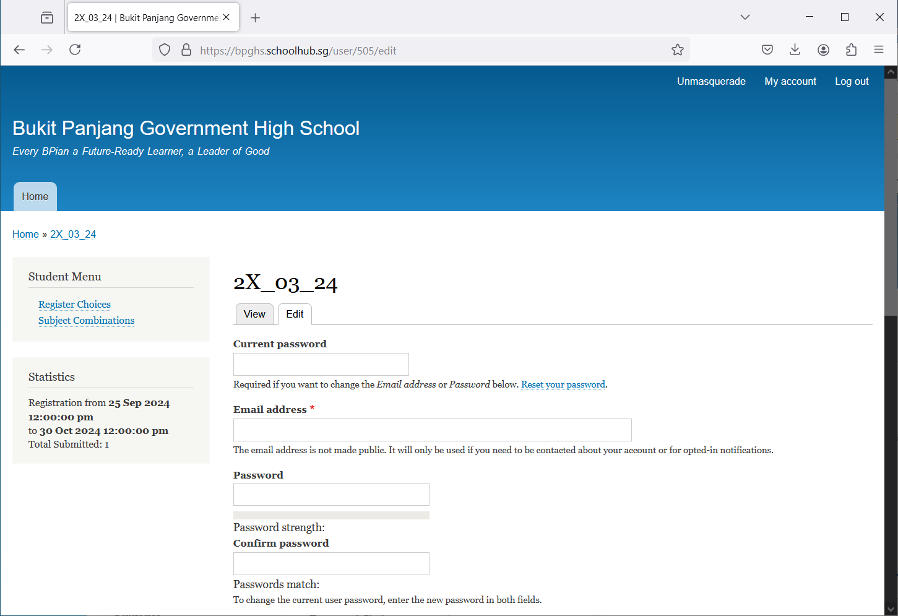

Click My Account

Steps

* Enter current password
* Update eMail Address
* Enter New Password (leave blank if you want to retain current password)
* Click on Save button

## View Subjection Combinations

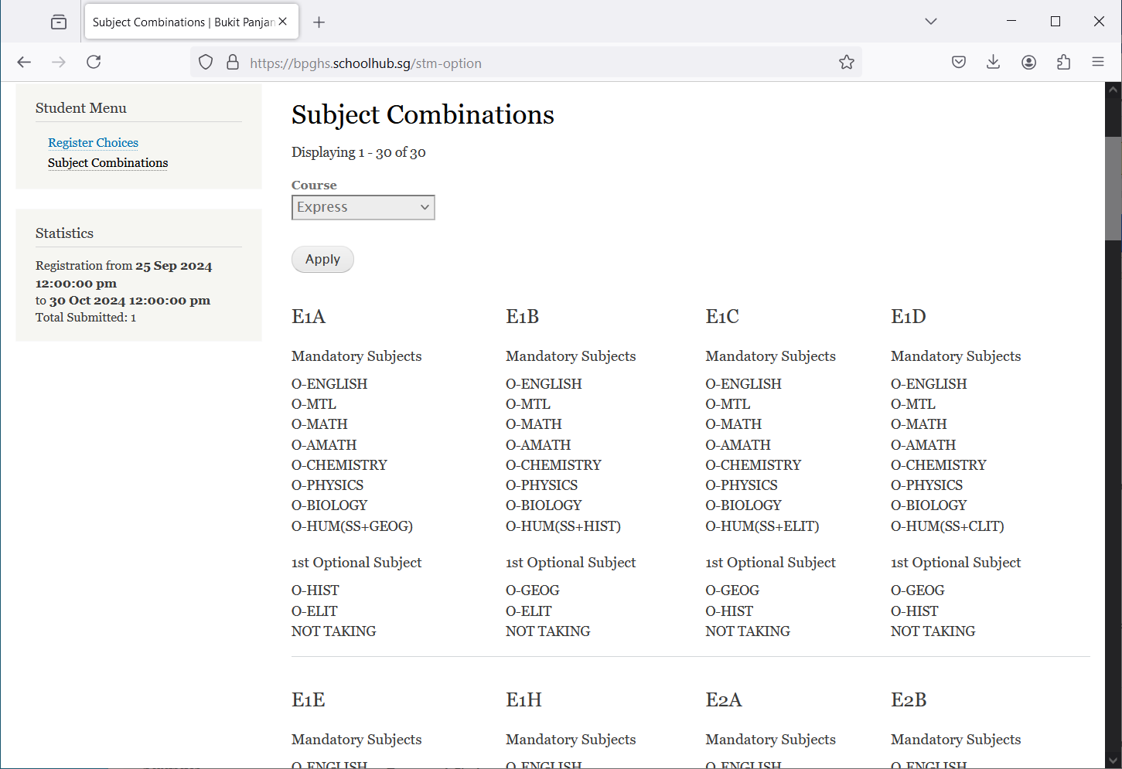

View Subject Combinations

## Register Choices

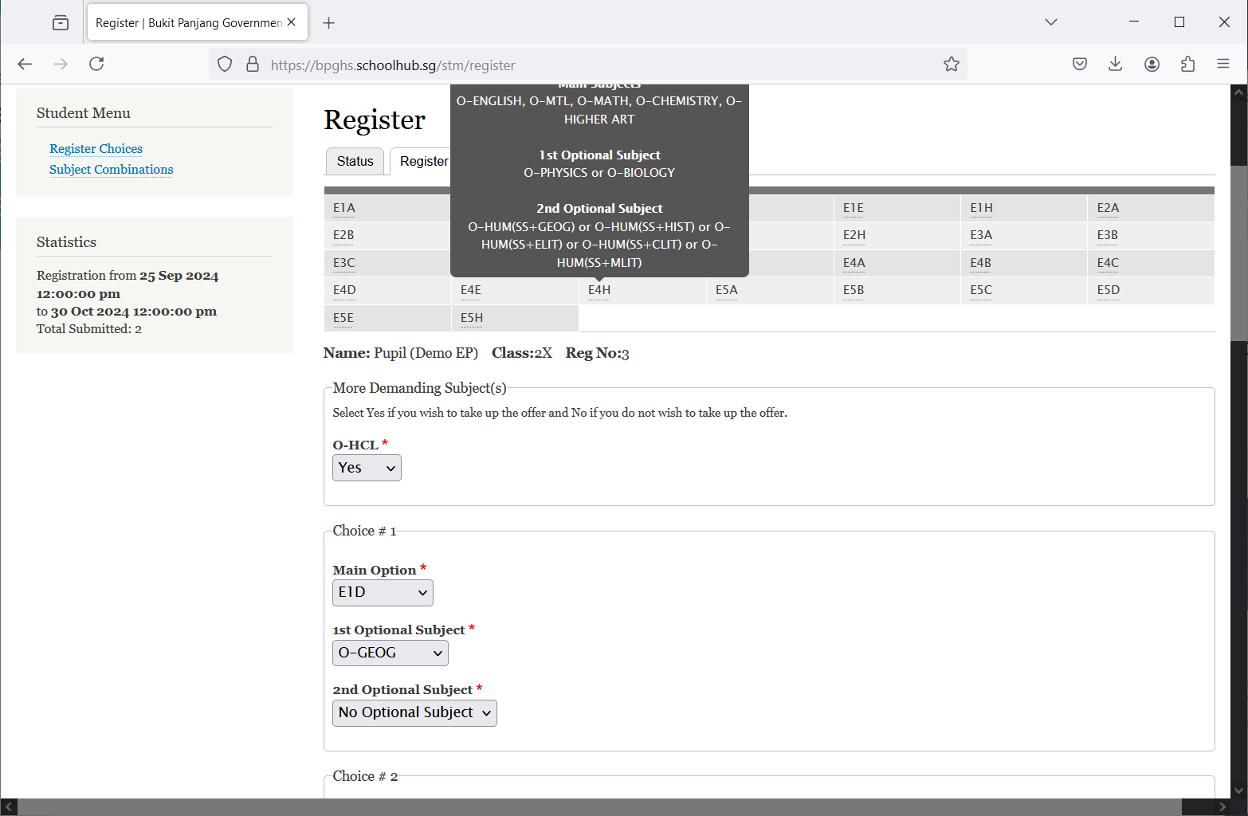

Enter all your choices

Indicate YES or NO

These are the list of Options you may choose from

Click Register Choices

Steps

* Click on Register Choices
* Update Your choices

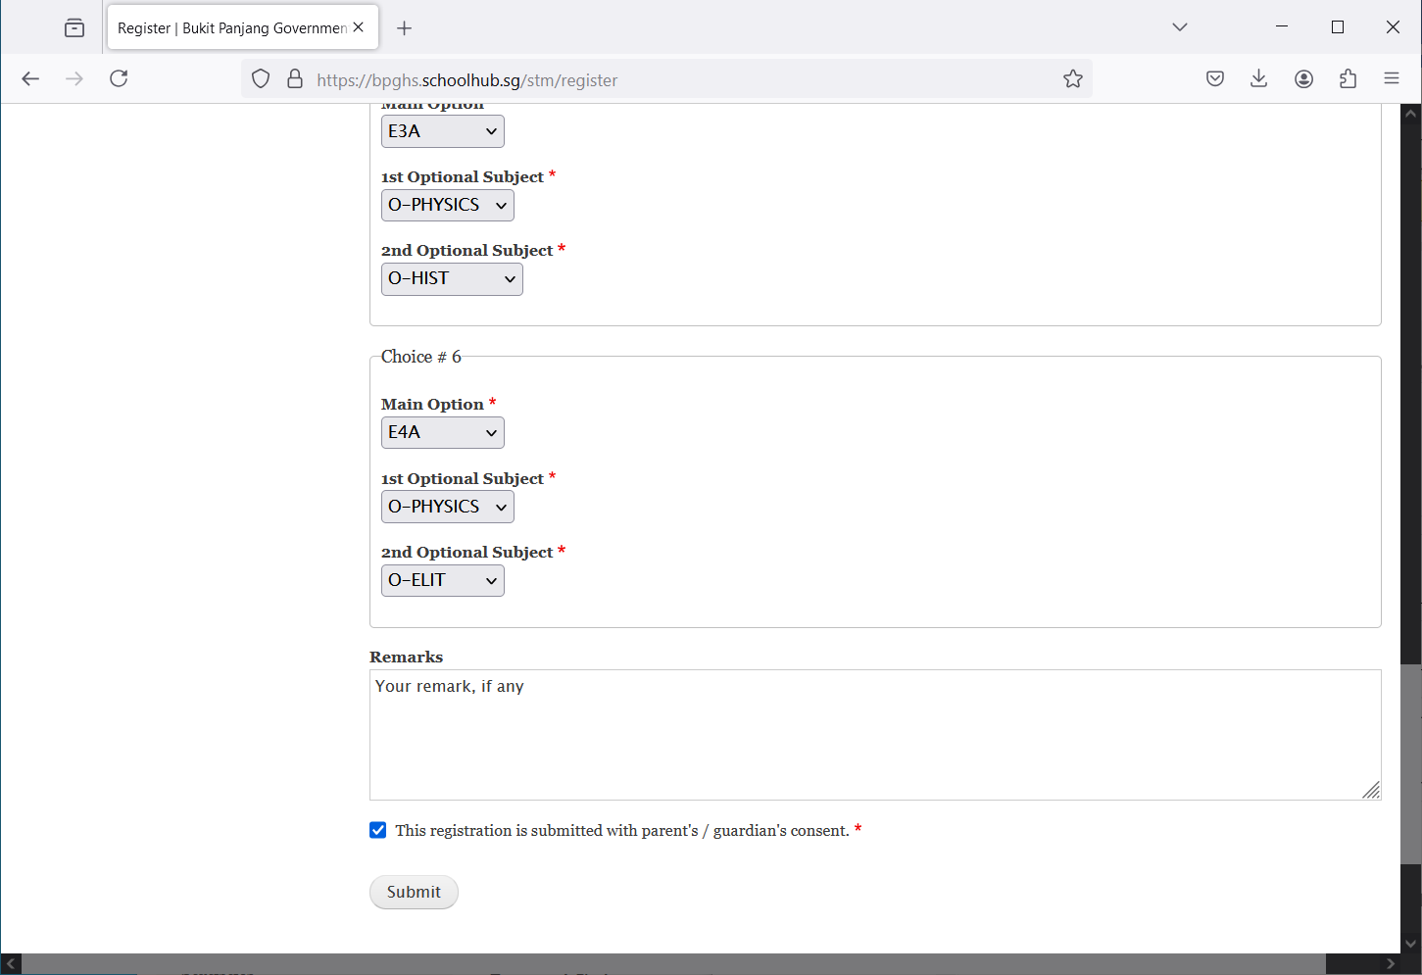

Click Submit

Enter any remarks for the school

Tick the box

* Click Submit at end of screen

Note:

You may change your choices any time before the closing date.

## 

## Print Confirmation Slip

Once you have Submit Successfully, you may proceed to Print the Confirmation Slip.

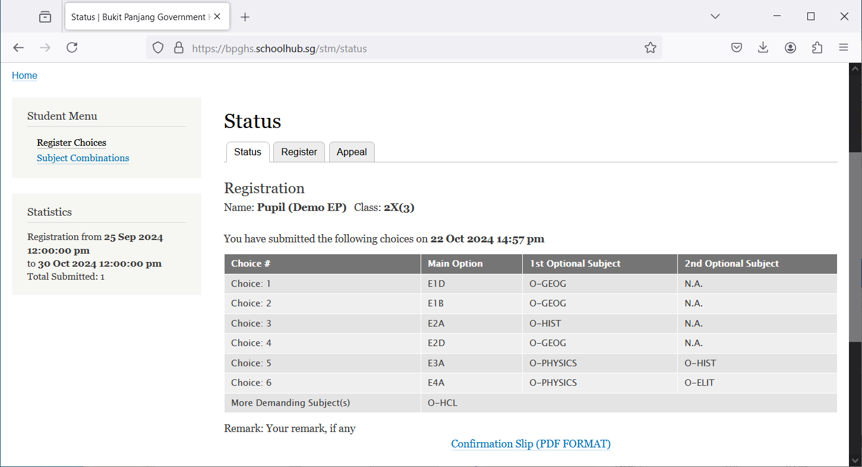

Steps

Print Confirmation Slip

* Click on Print Confirmation Slip (PDF Format)
* The hard copy confirmation slip must be signed and filled in with a contact number before submitting to General Office

**Sample Confirmation Slip**

