**Bukit Panjang Government High School**

**Subject Combination Option User Guide for Students (NA/NT)**

**URL: https://bpghs.schoolhub.sg**

## Log in

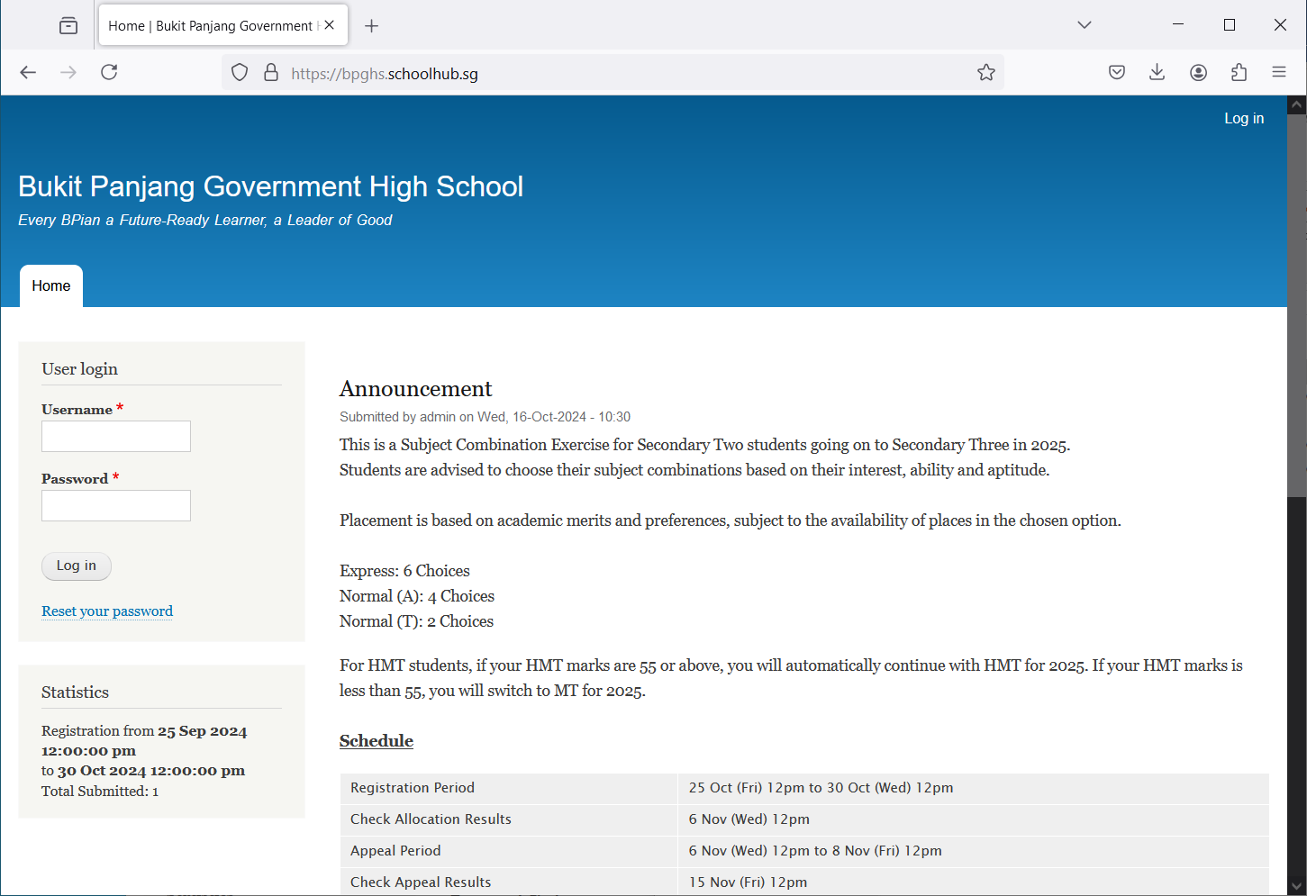

Steps

* Enter Username

**Password Format**  
Password is date of birth in   
ddmmyyyy format

**Username Format**  
Username is first 5 characters of name and last 3 digits and alphabet of NRIC

Eg LEONA123G

* Enter Password
* Click on Log in button

## Main Menu

Update your Account

Upon Successful login, you will see the main menu

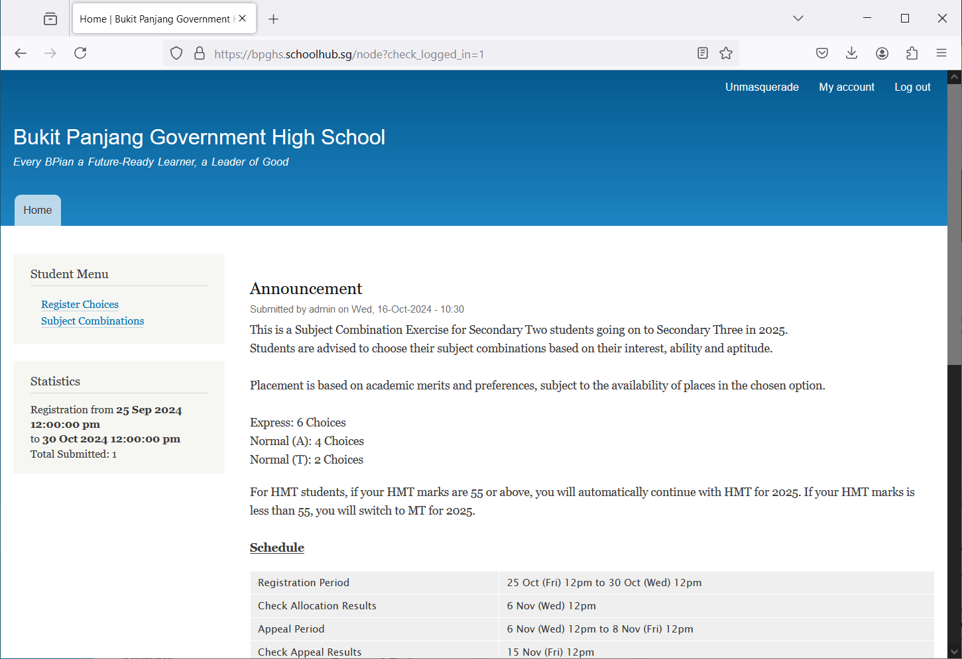

All Announcements will be posted here.

View all Subject Combinations

Update your choices

Send eMail if you have issue

## Update User Account

You may change your password and update your eMail before you proceed to your Subject Combination choices.

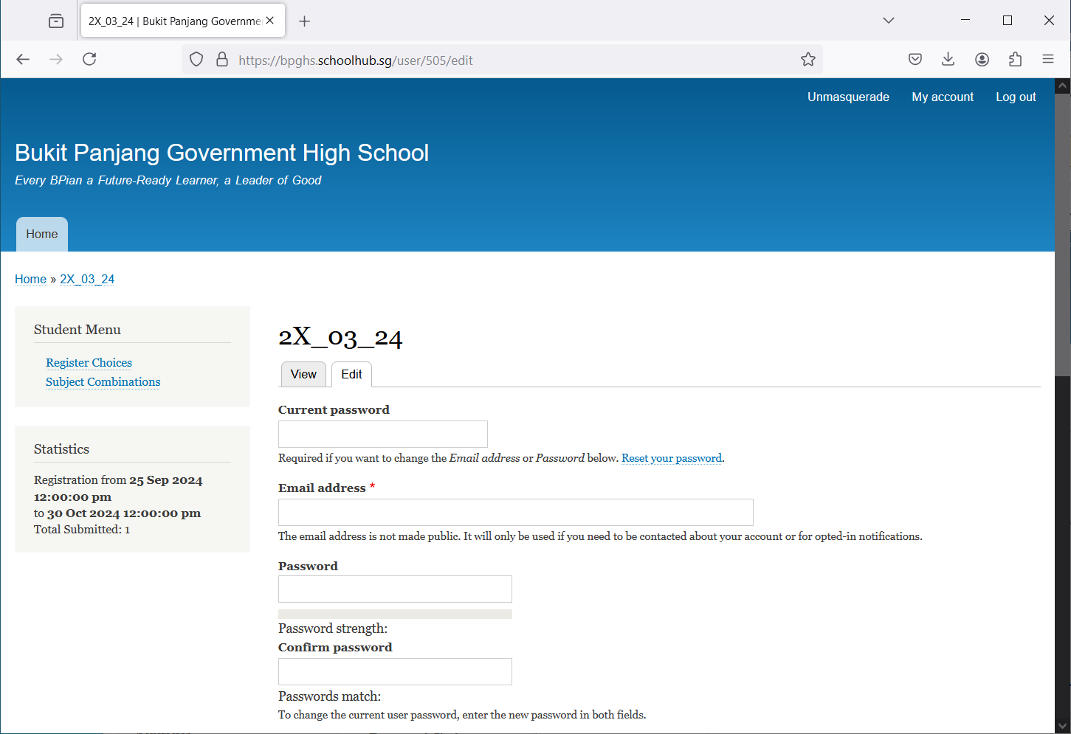

Click My Account

Steps

* Enter current password
* Update eMail Address
* Enter New Password (leave blank if you want to retain current password)
* Click on Save button

## View Subjection Combinations

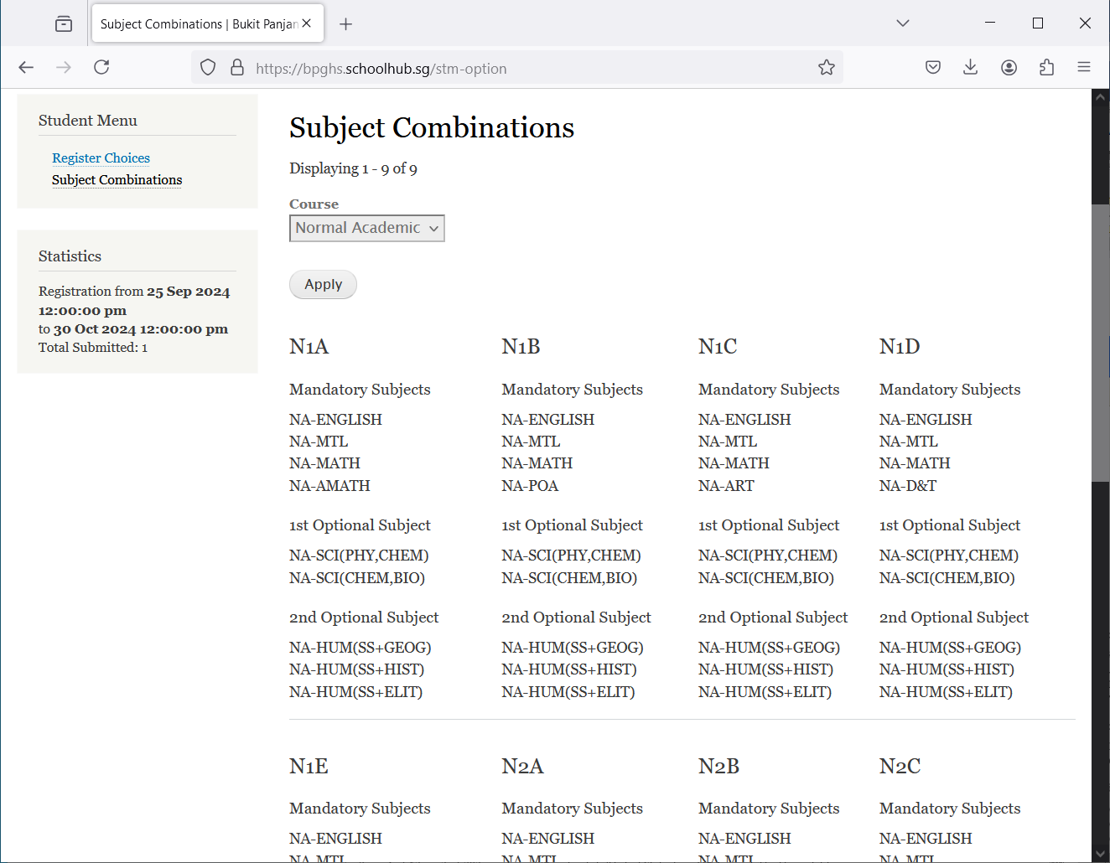

Click Subject Combinations

## Registration of Choices

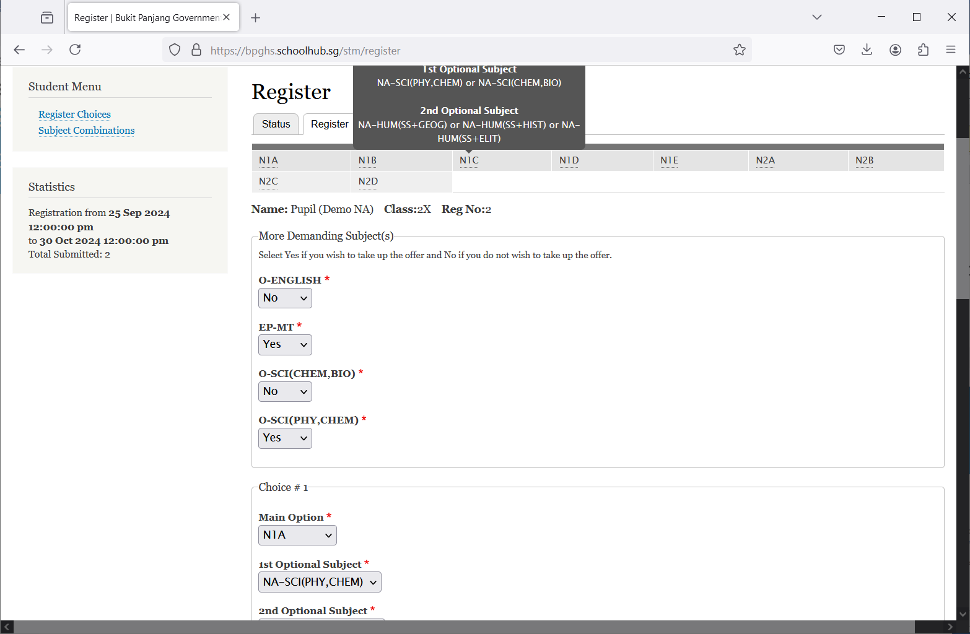

Indicate YES or NO

Click Register Choices

These are the list of Options you may choose from

Steps

* Click on Register Choices

Enter all your choices

* Update Your choices

## 

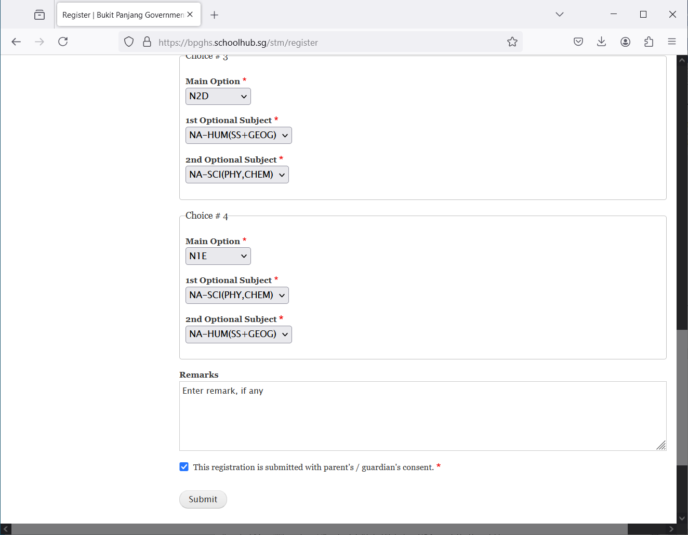

Enter any remarks for the school

Tick the box

Click Submit

* Click Submit at end of screen

Note:

You may change your choices any time before the closing date.

## Print Confirmation Slip

Once you have Submit Successfully, you may proceed to Print the Confirmation Slip.

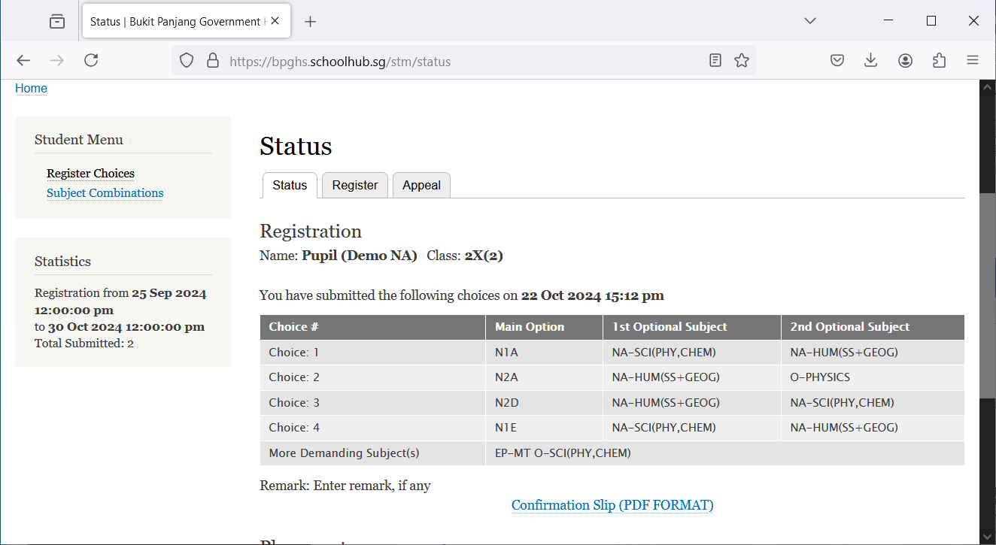

Steps

Print Confirmation Slip

* Click on Print Confirmation Slip (PDF Format)
* The hard copy confirmation slip must be signed and filled in with a contact number before submitting to General Office

**Sample Confirmation Slip**

